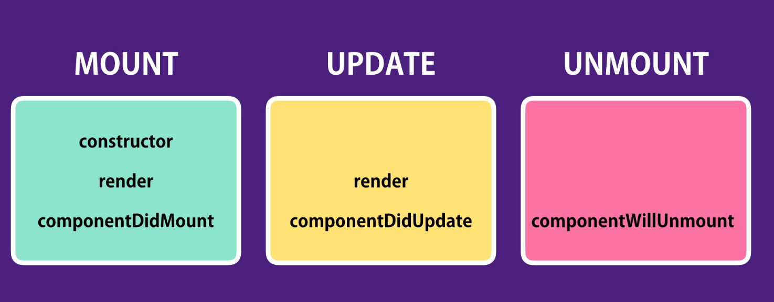

In each phase, react will call those hooks in order. These are most frequently used hooks, there are more hooks, but they are rarely used.

**Mounting Phase:**

* **Constructor:** This constructor is only called once, when an instance of a class is created. Most common use case is to set the state based on the props we receive. In other words, initializing the properties of the class.

Note: we don’t have access to setState here, infact it would be an error. Also, to access props, we must pass the props to constructor and inside the contructor on super.

* **ComponenentDidMount:** This method is called after the component is rendered into the dom. Most common use case is to make ajax calls to get data from server.
* **Render:** One thing to notice here, is when a component is mount, all its children are also mounted recursively.

**Update Phase:**

* **ComponentDidUpdate:** Here we can get the old props and old state and check if there are any changes to props or state. We can do check and make ajax call to server to get data if the state or props is changed.

**Unmount Phase:**

* **ComponentWillUnmount:** This method is called just before the component is unmounted from the dom. Typical use case of this method is to do cleanup timers, event listeners etc.